**MERN Final Project (Login Page and Logged in User Flow)**

1. *Login Page :*

Logged in User will be shown these below Nav links (profile, Logout links will be additional)

<http://localhost:4200/>

Home Page will be same for both Login User and Guest User.

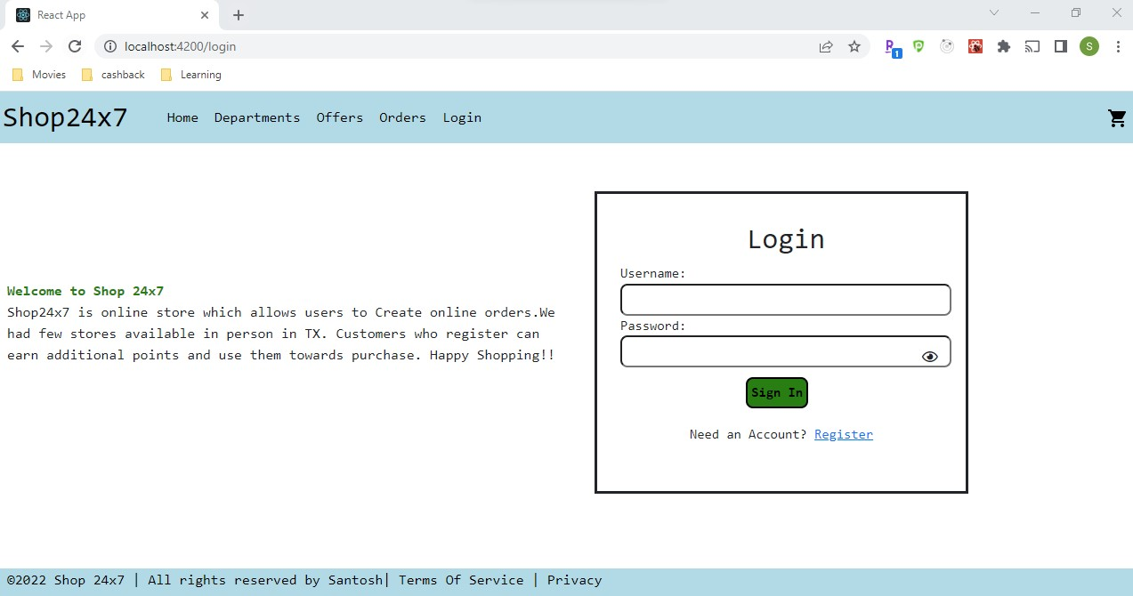

Validations:

1. Check for null fields
2. Password should be min 8 chars
3. Check for non-existing user and provide message – “User Not exist. Please register”

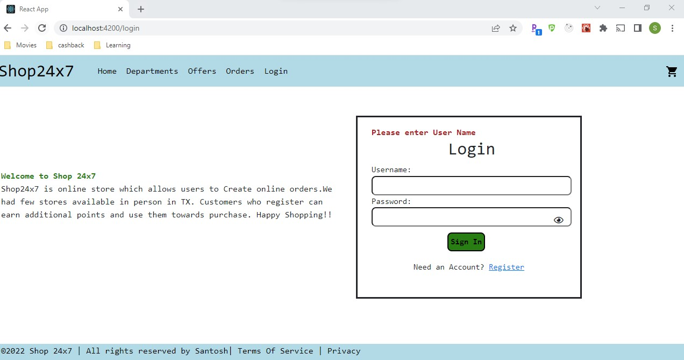

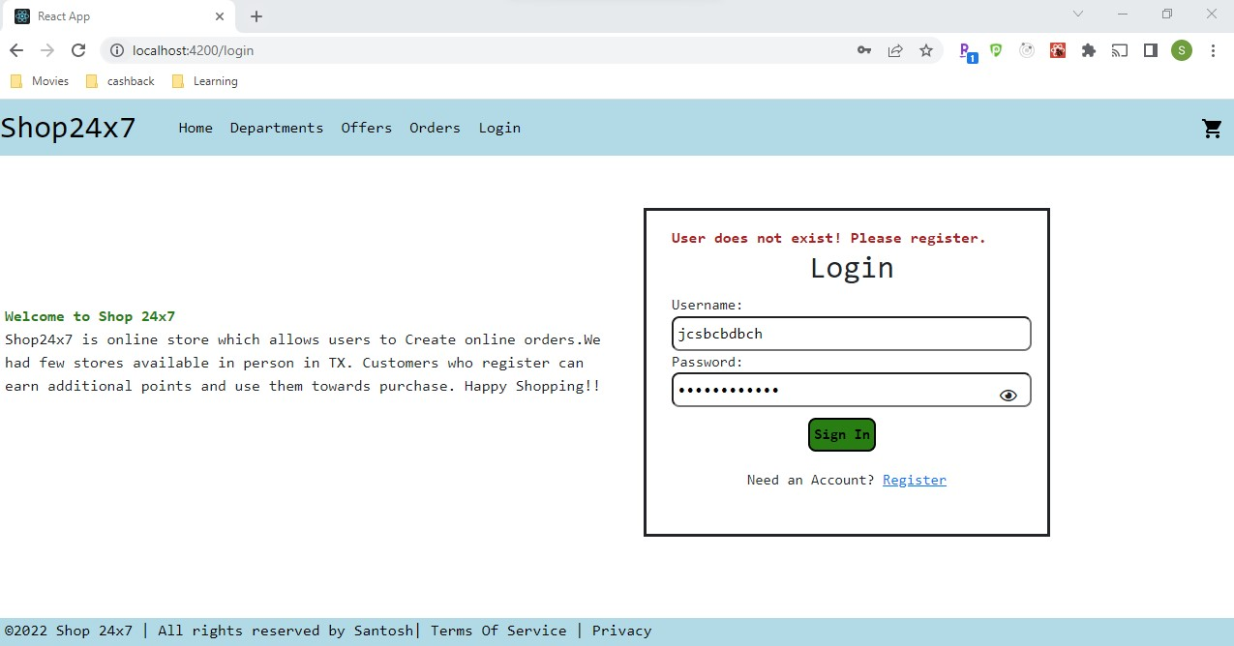

After successful login, User will be directly navigated to Profile Page where user can update address, add profile photo and delete photo

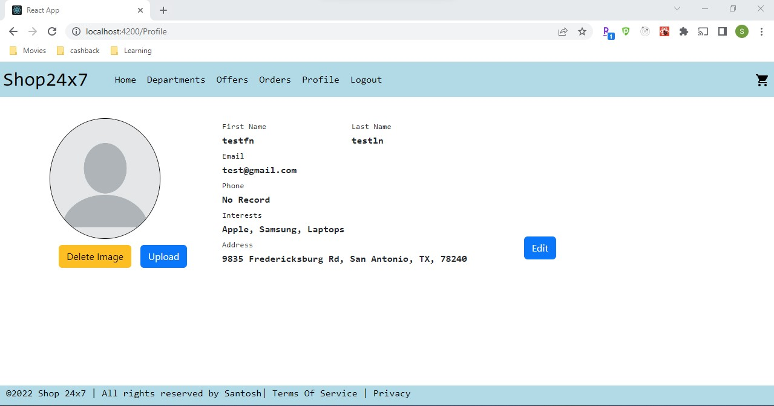

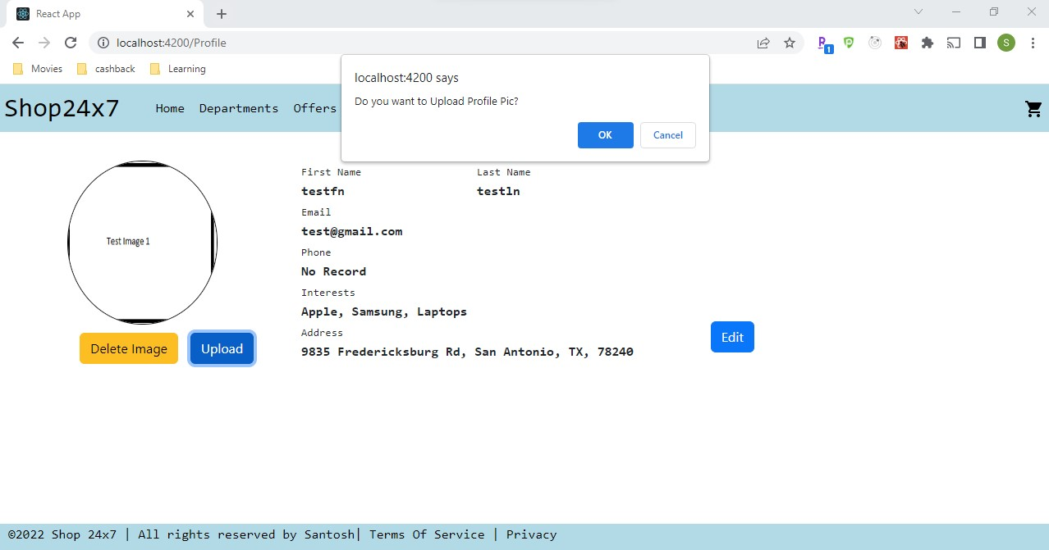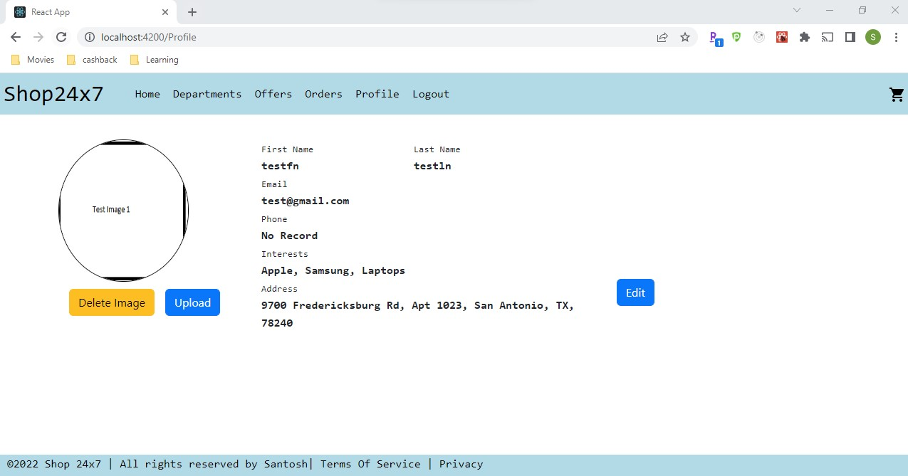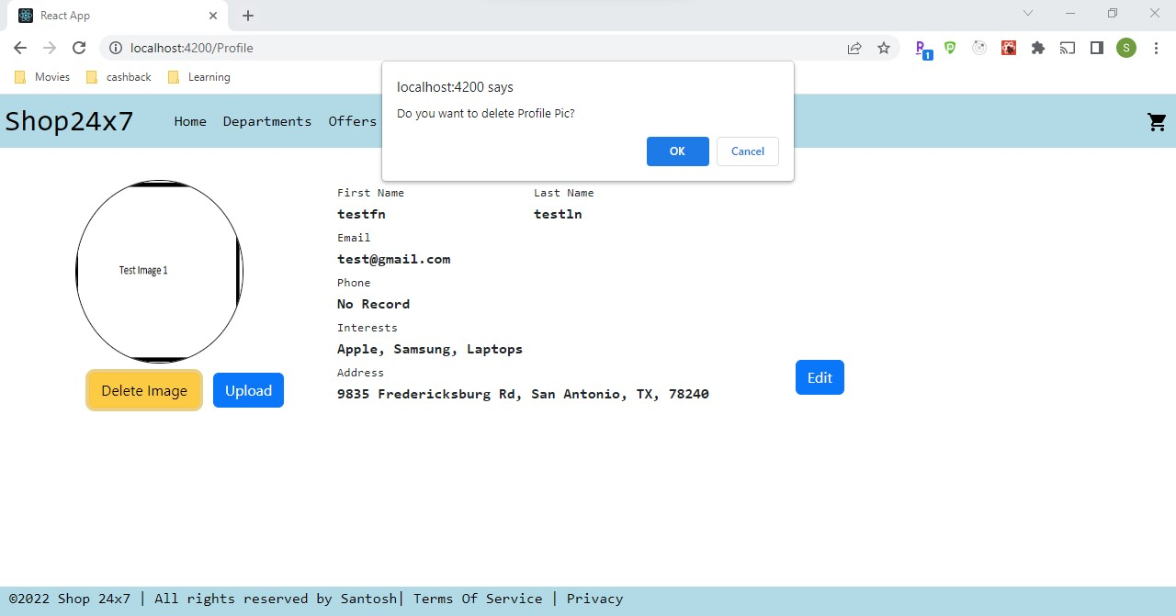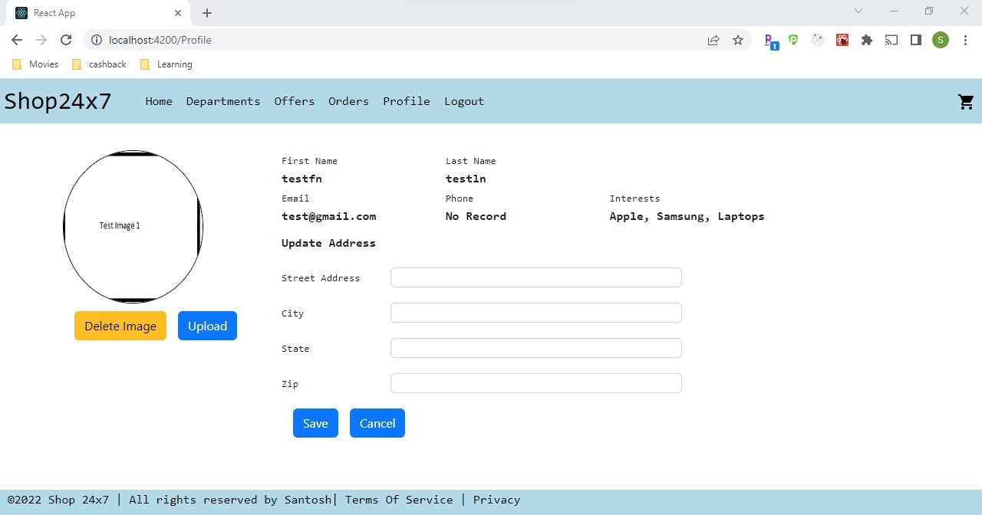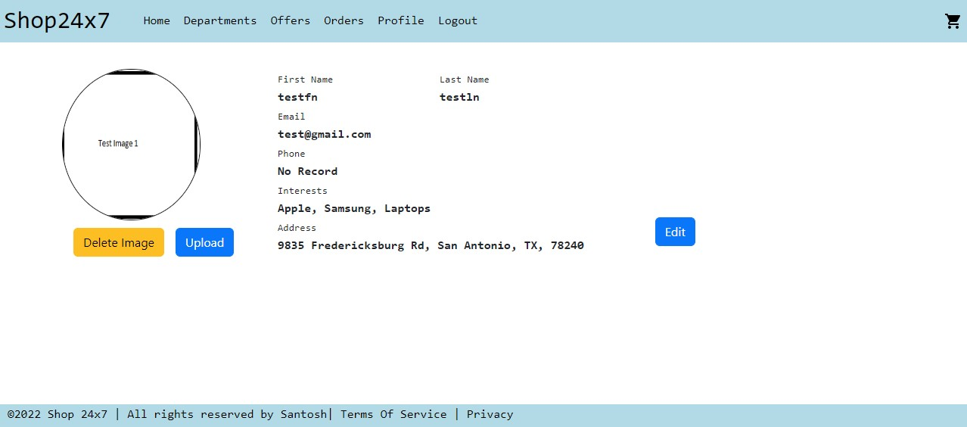

Home Page will be same as guest user except the Nav links Carousel (default), Categories (3 random Categories) and Top Selling Products (random 8 products)





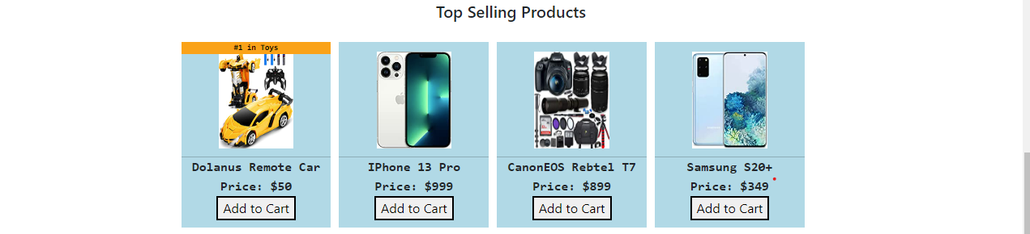

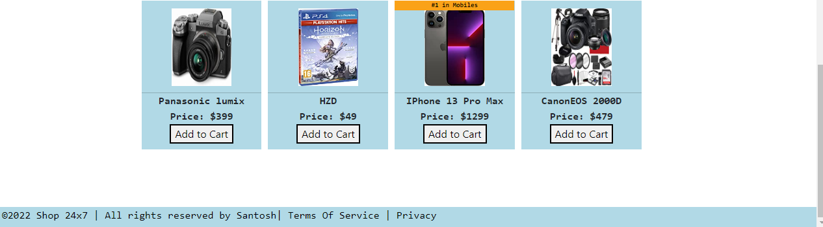

Top Selling Product will be shown with tag #1 in <Category Type>

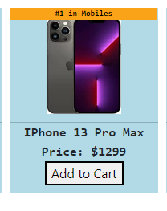

Departments Page – Guest / Logged in User can browse products by Categories <http://localhost:4200/Department>



Products Under Category - <http://localhost:4200/Categories?categoryName=Mobiles>



Filter by Price and Search

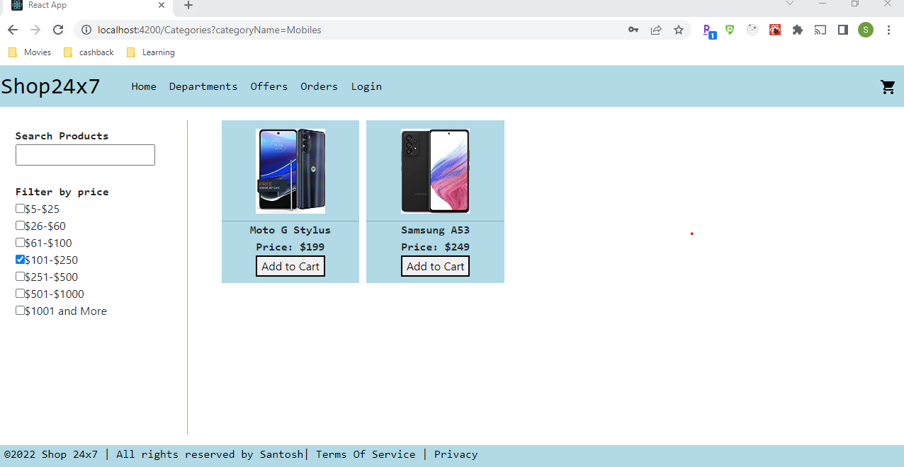

Search

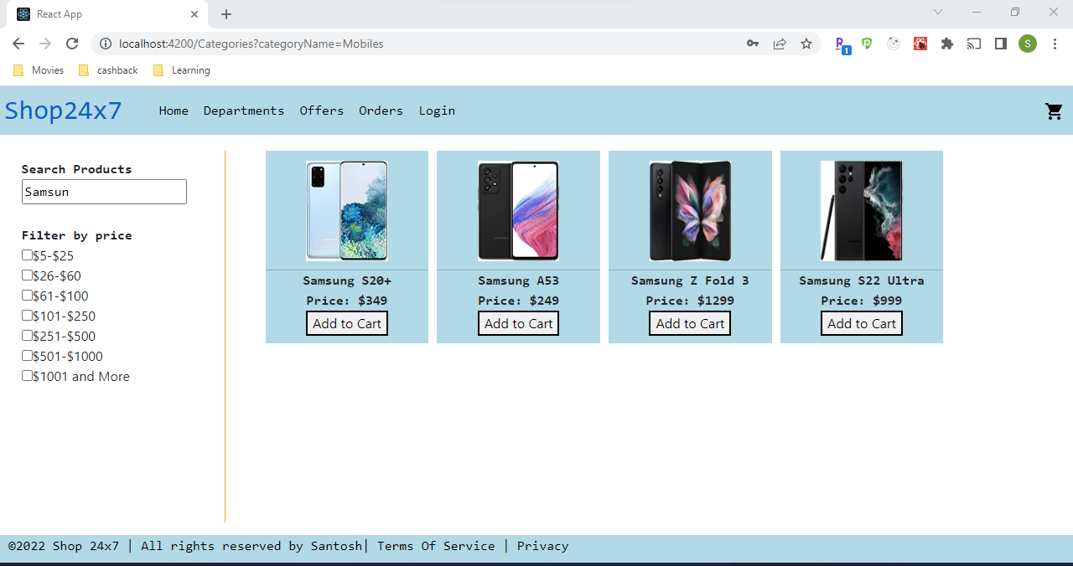

Cart Count will be updated automatically by adding products

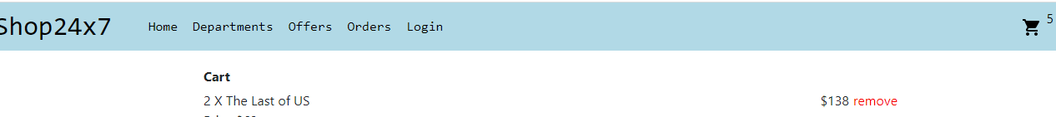

Cart Page - <http://localhost:4200/Cart>

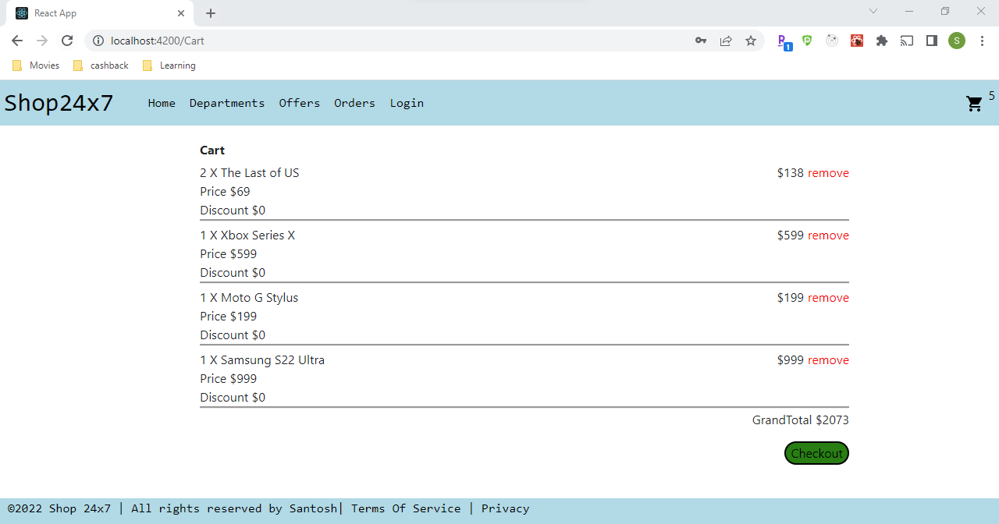

Products can be removed from Cart by clicking on remove button. Updated Cart after removing 2 products from above list

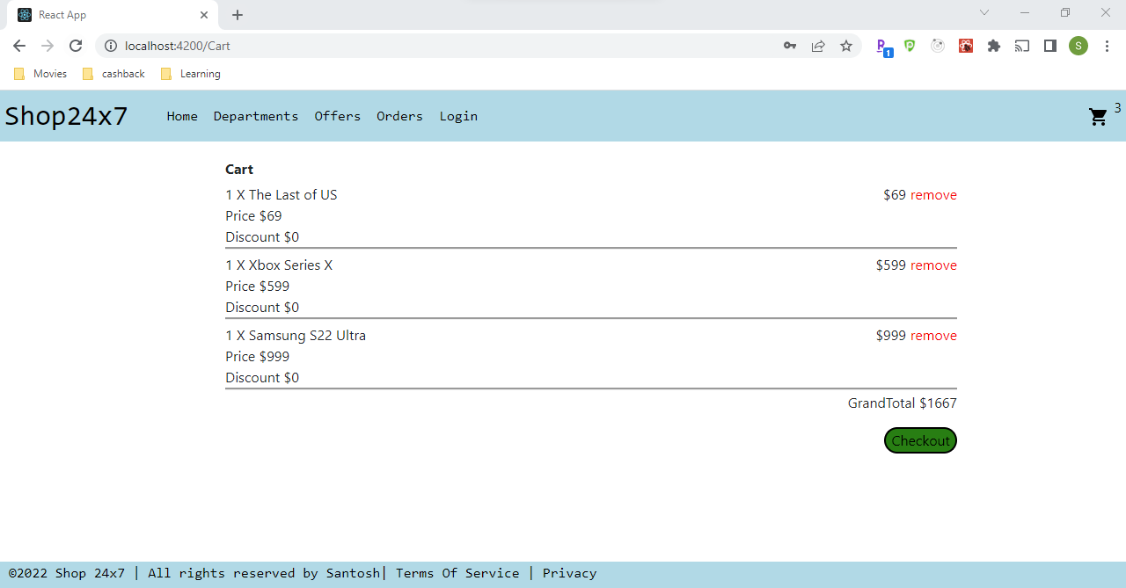

On Click of Checkout Guest will be redirected to checkout page to provide user information and shipping address

<http://localhost:4200/checkout>

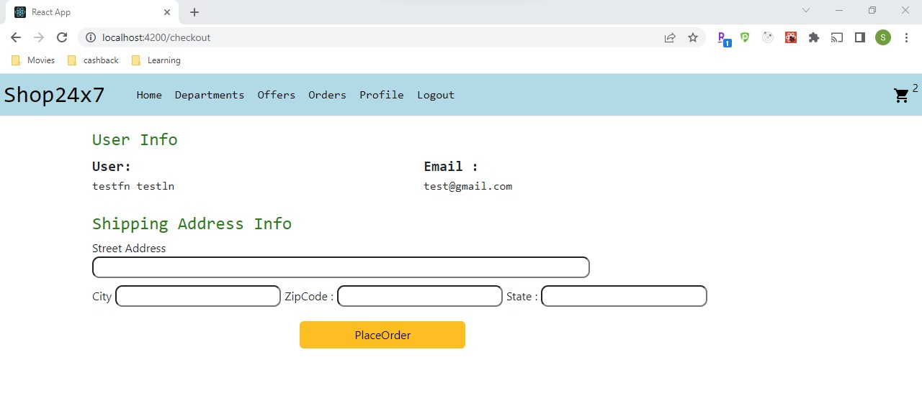

Validations:

Logged in user has to provide all shipping info else they receive error – “Please enter Shipping details”

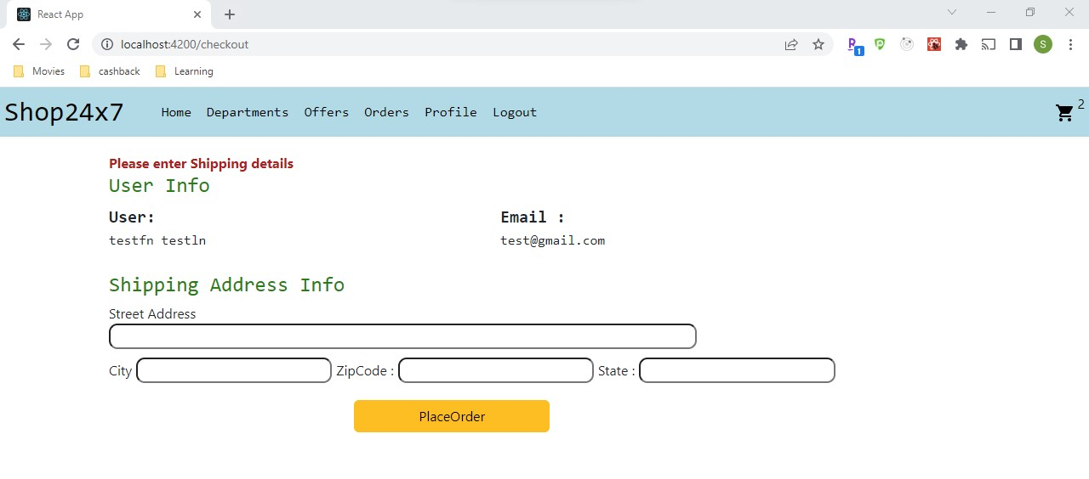

After Validations are success, User will be able to proceed further by placing order and will be redirected to orders page <http://localhost:4200/orders>

